**Difference between Javascript and JSON:**

|  |  |
| --- | --- |
| Javascript | JSON |
| It is more flexible in the sense of syntax | It is more rigid |
| The objects can be defined as:  “name”:”value”  ‘name’:”value”  name:”value”  ‘name’:’value’ | The objects can be defined ONLY as  “name”:”value” |
| Chances of doing error is very less. | Comparatively more chances. |

console.log() -> to give print command within the javascript and the json

Try to print the console.log() through both:

1. the directly reloading browser for .html file inside which is the javascript file, in dev. tool
2. and, writing directly to dev. tool console

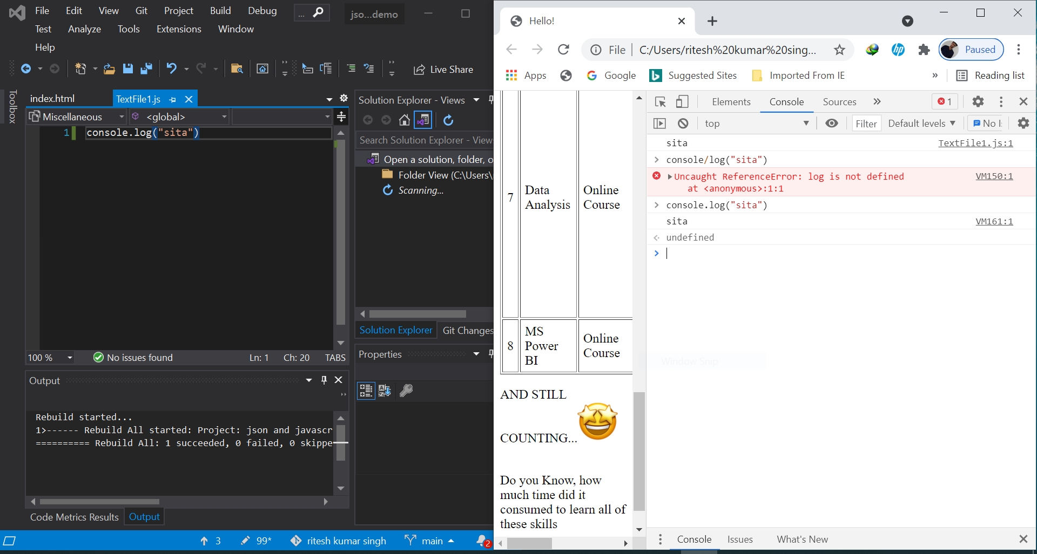Fig1: using both the Dev. Tool console and the VS editor to print the changes

**\*\*\*NOTES:** DO NOT TRY TO VIEW CHANGES ON BROWSER BY RELOADING WITHOUT “SAVING” THE CHANGES IN THE LOCAL FILE.

console.log(object_name) -> to show the stored data inside the object_name

console.log(“string”) -> to print the string as it is.

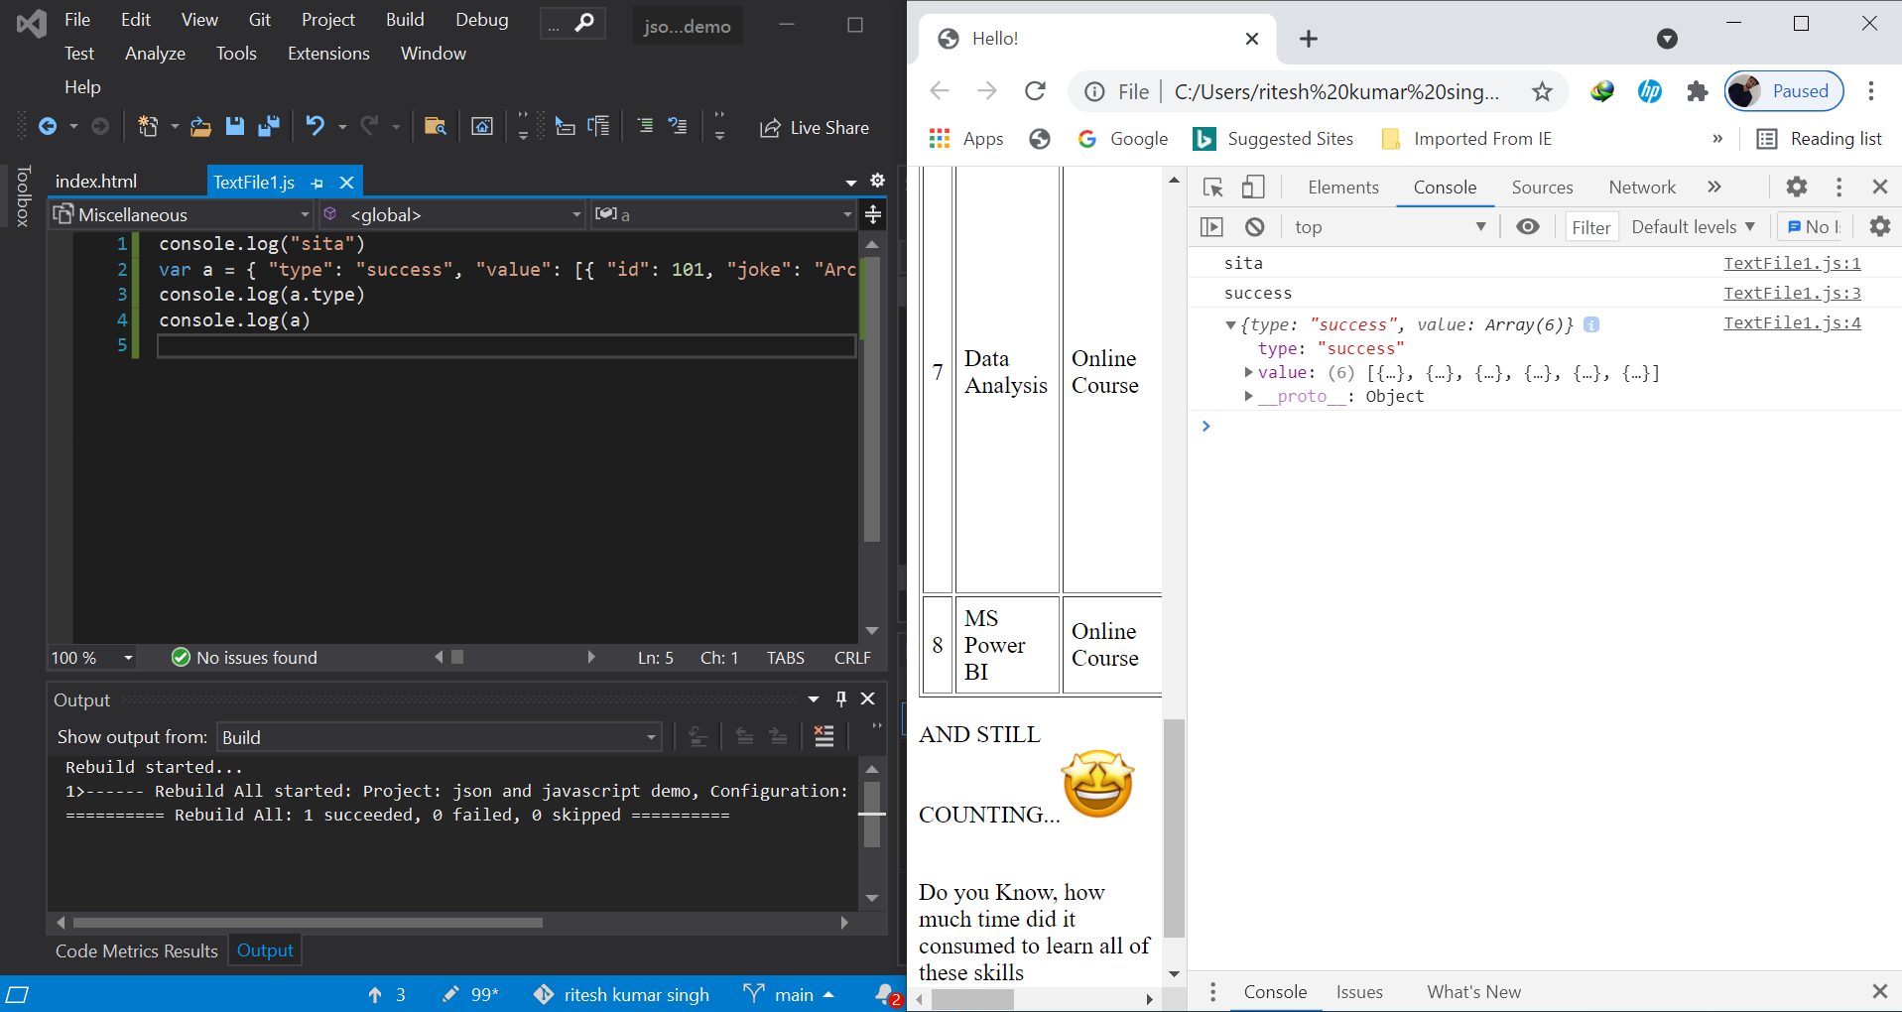Fig2: querying the objects (“STATICALLY”)

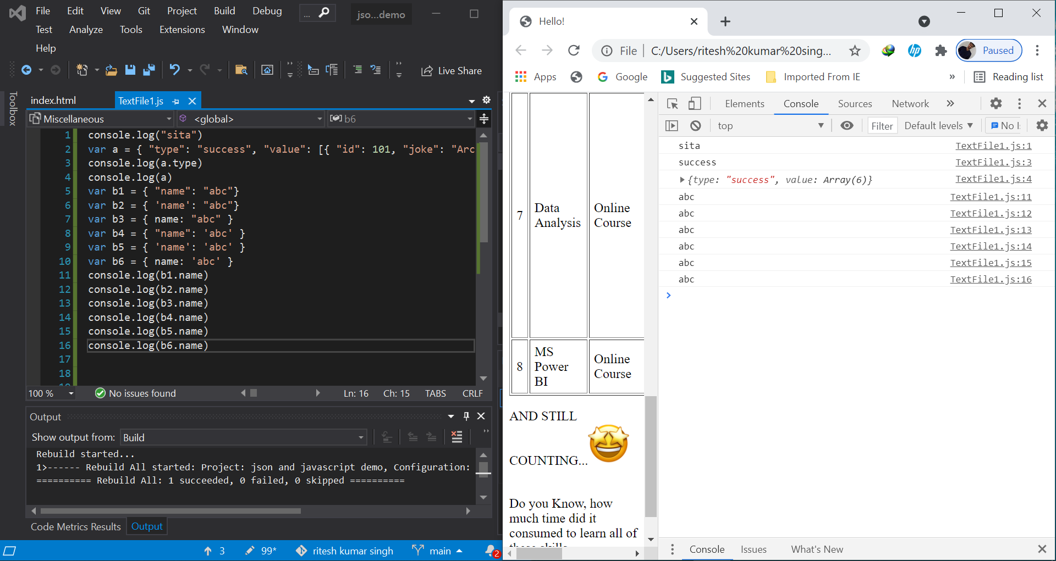Fig3: All possible variations to describe any object

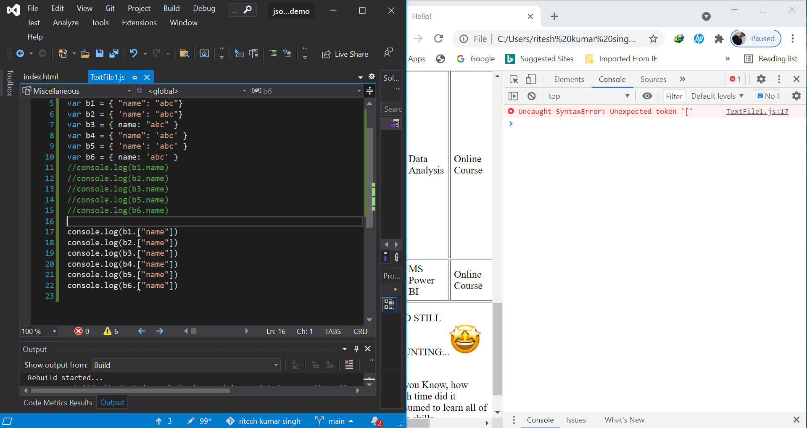Fig4: incorrect format to access the values inside object

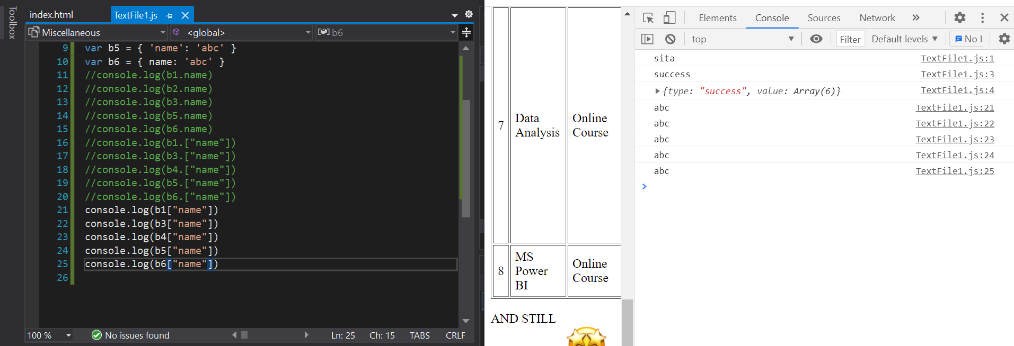Fig5: correct format to access the values inside object

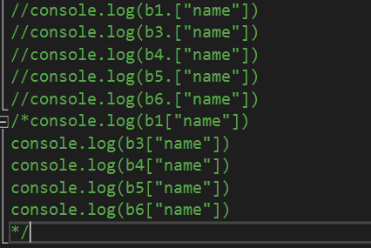

Fig6: Shortcut to comment out than commenting all the lines individually

**Dynamically query Object and its variables:**

* **querying the objects (“DYNAMICALLY”)**

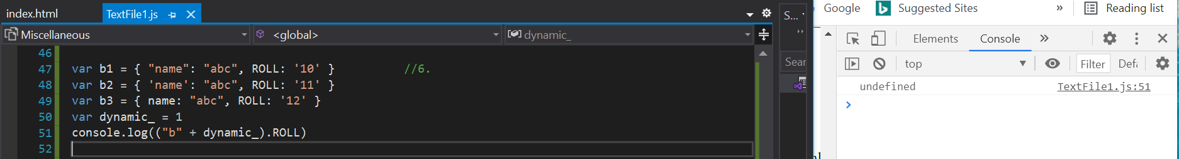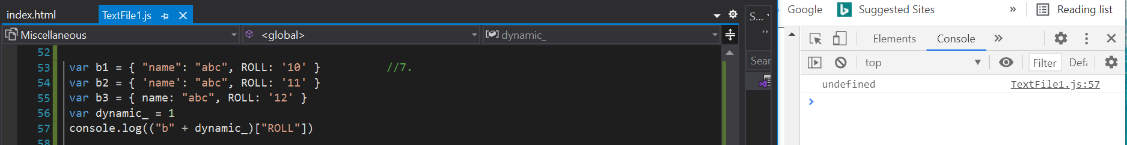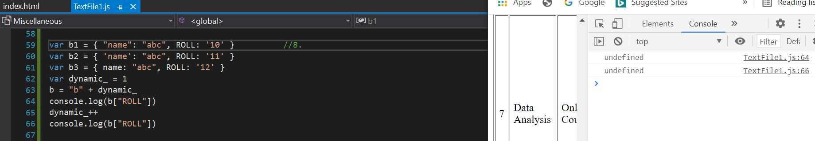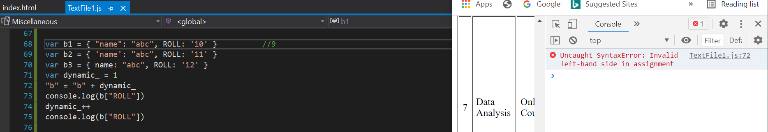Fig7: **INCORRECTLY** dynamically calling objects generating errors

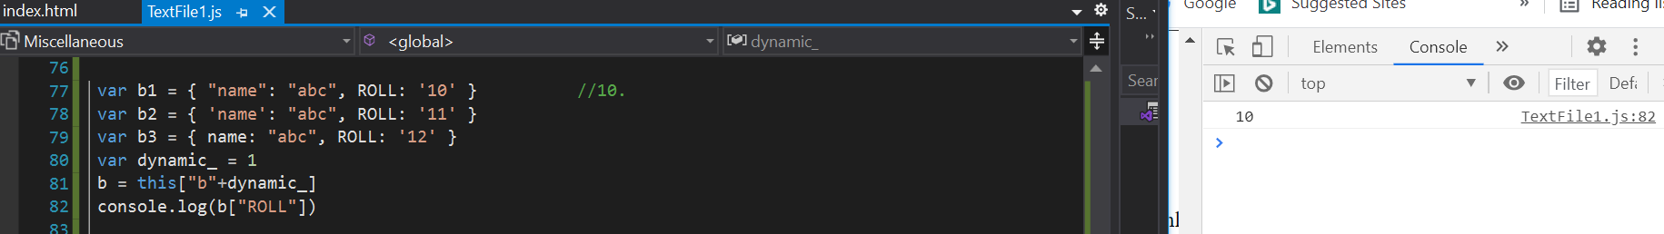Fig8: **CORRECTLY** querying the objects (“DYNAMICALLY”). Use this[] command to search string into the windows object

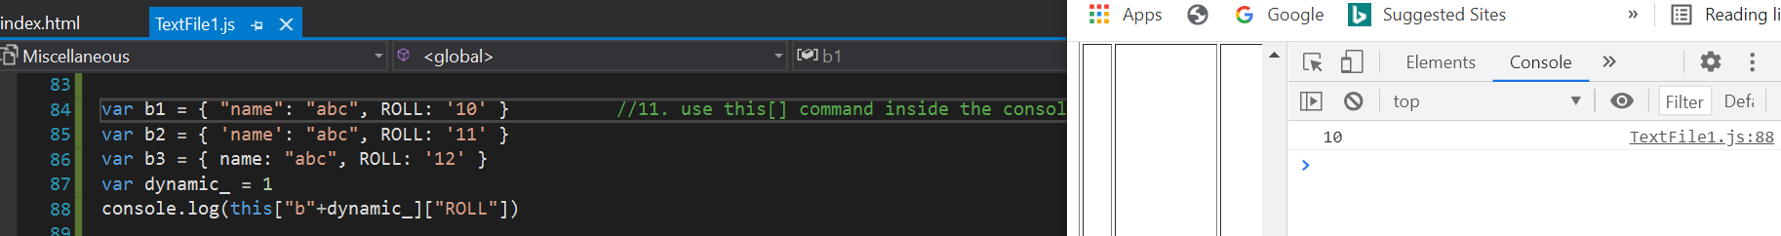Fig9: querying the objects (“DYNAMICALLY”). Use this[] command inside the console.log()

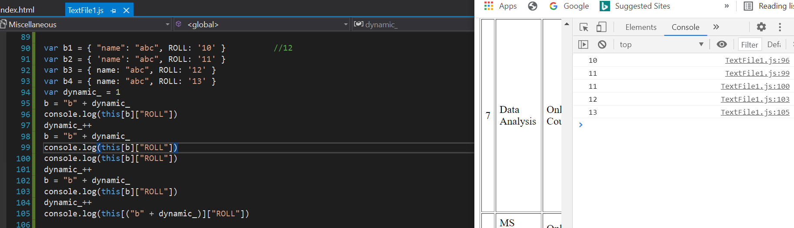Fig10: Dynamically object-looping + testing pre-increement operator

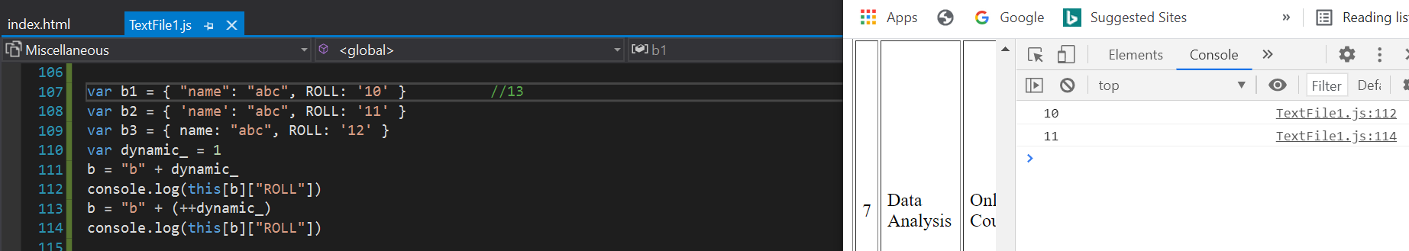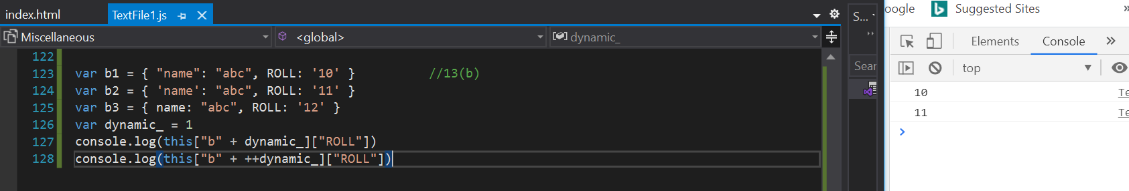Fig11: Dynamically object-looping (post-increement operator)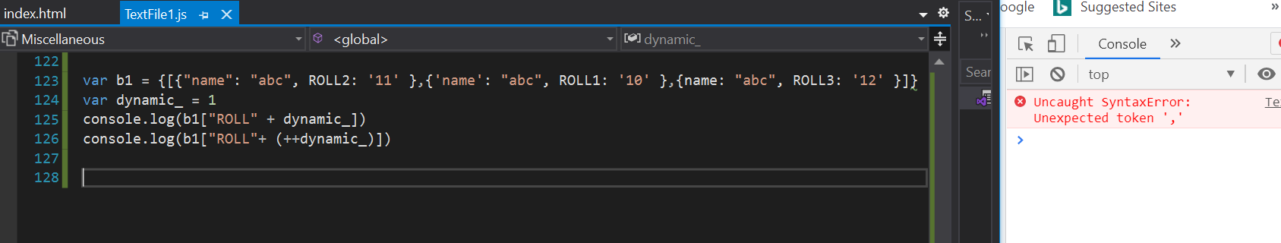fig12: Incorrect Dynamically variable-accessing (SYNTAX ERROR-> INCOMPLETE {[]: } )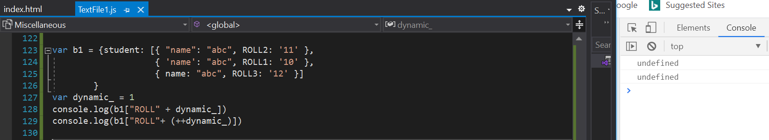fig12(b) : Incorrect Dynamically variable- as-array accessing (undefined-> no element as[“ROLL”] inside b1)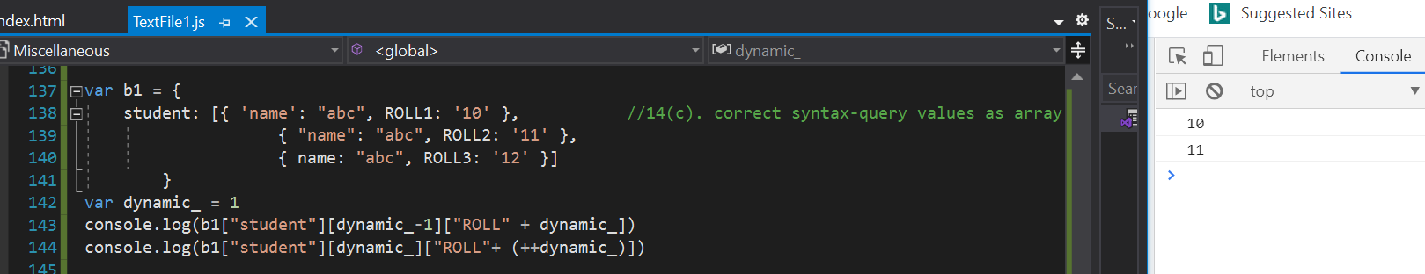fig12(c): Correct Dynamically variable-as-array accessing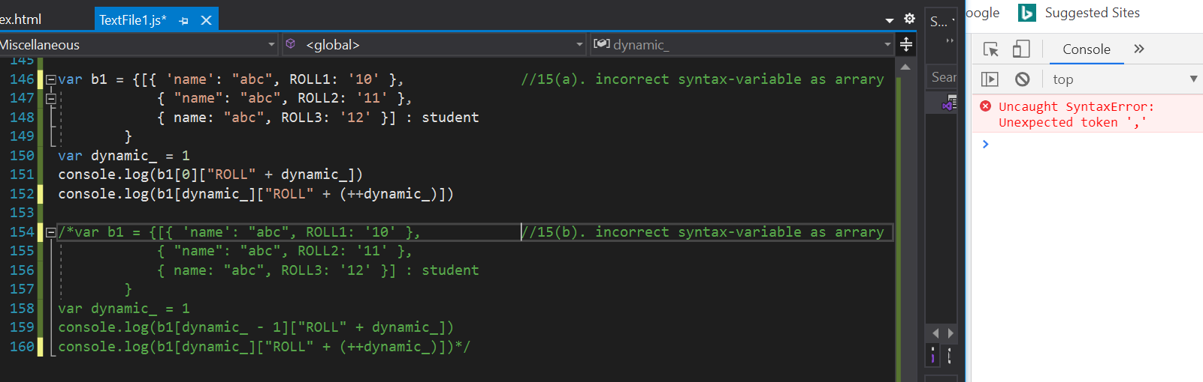Fig13: Incorrrect dynamic variable-as-array accessing (same syntax error for both 15(a) & 15(b))

***NOTES: Obect always described in key-value pair, List is kind of value, Value always comes last.

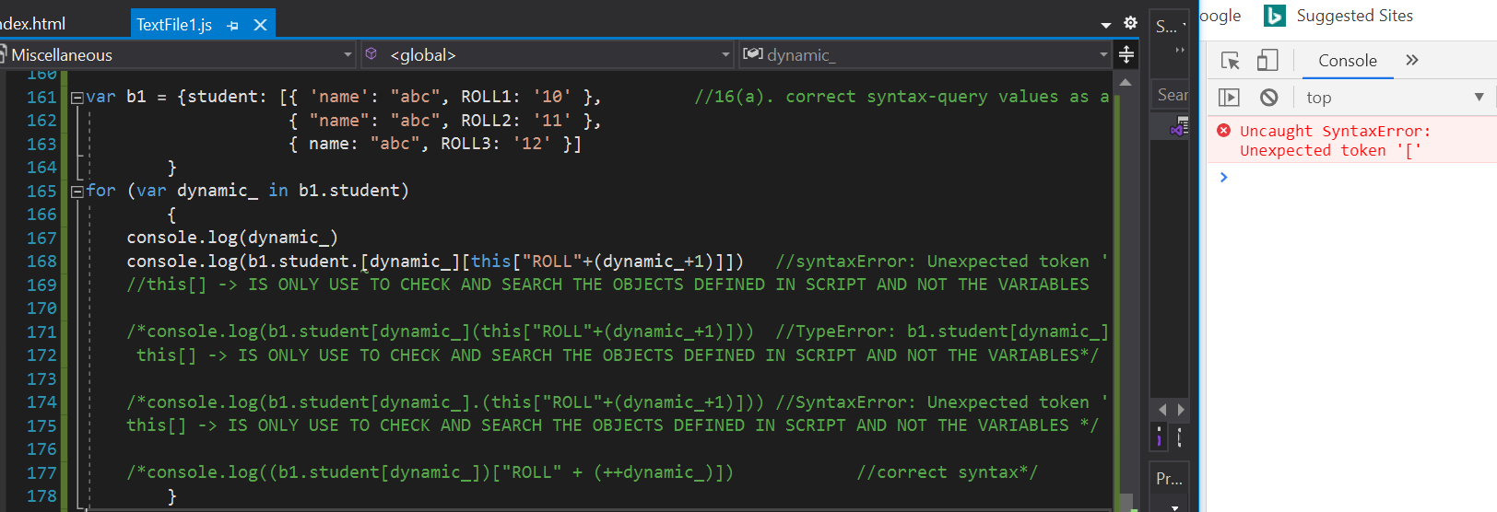Fig14(a): Incorrectly Dynamically looping through variables(error 1:SyntaxError)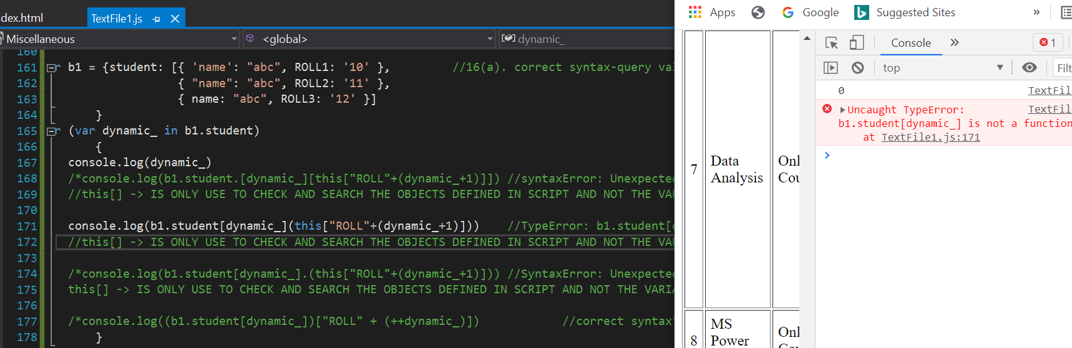Fig14(b): Incorrectly Dynamically looping through variables(error 2:TypeError)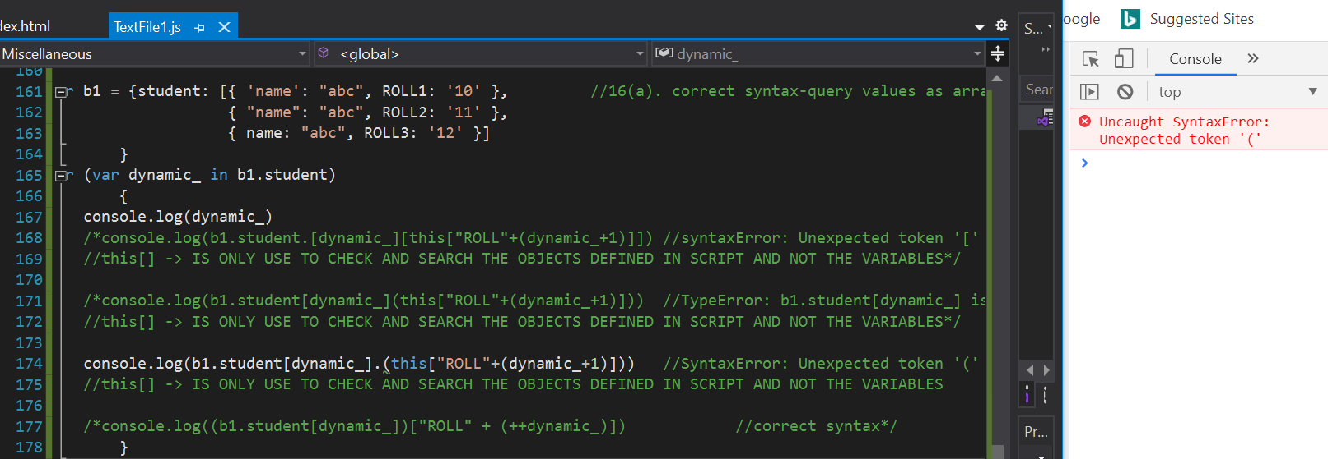Fig14(c): Incorrectly Dynamically looping through variables(error 3:SyntaxError)

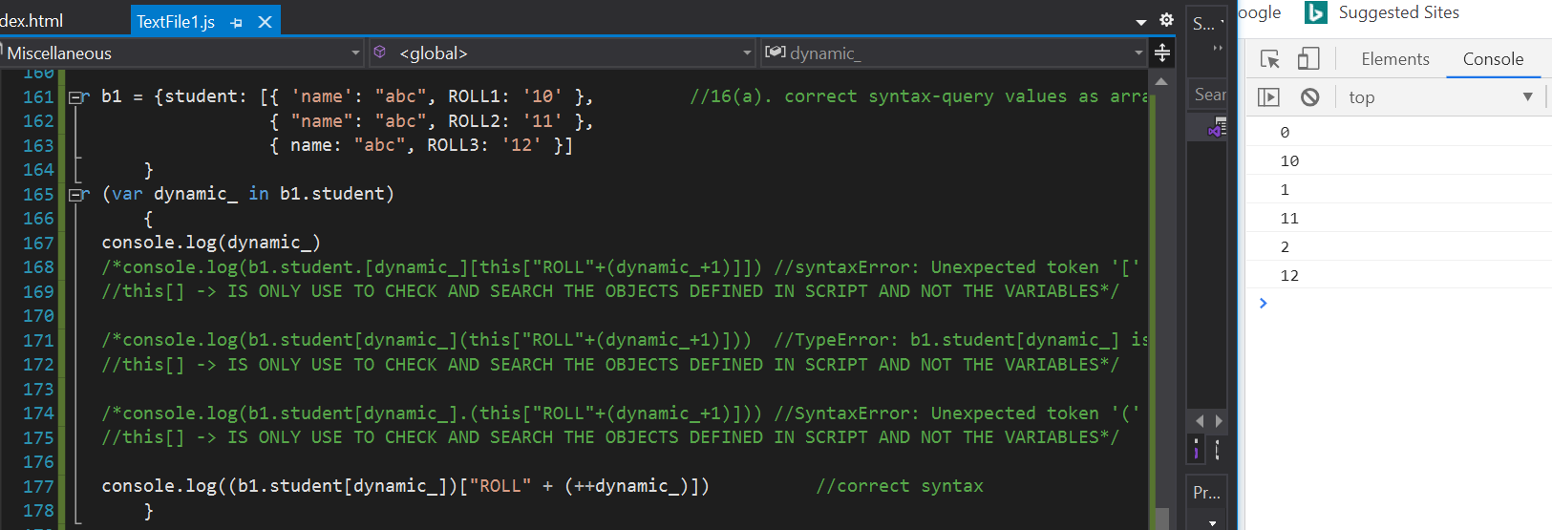Fig14(d): Correctly Dynamically looping through variables